REFLEXIO
  - Devansh Gupta, Mengxiang Jiang, Arthur Lanclos, Alan Liang, Brendan Viscomi

Class Responsibility Collaboration Tables

Controllers

GameEngine
Description: The GameEngine is a igh level class that causes the game to update and draw every frame.
Justification: Only one class is required for drawing to the screen every frame, so it should be a single class.
Class: Controller
Responsibility | Collaboration
Get player input | Controller
Get input while game is paused | PauseController
Get input while displaying main menu | MenuController
Main draw: draws all objects in the world | LevelView, MenuView, PauseView
Sets game parameters and loads a world | LevelCreator
Change the game mode between paused, main menu or play mode depending upon the key pressed | GameEngine

Controller
Description: Depending on the current game state, the Controller either controls the movement of the player’s avatar or the interaction with the game’s menus.
Justification: Only one class needs to receive player input, so it should be a single class
Class: Controller
Responsibility | Collaboration
Reporting movement events | Level, PhysicsObject (specifically Player.cs)
Reporting reflection events | Level, PhysicsObject
Reporting menu events | MainMenu, PauseMenu

LevelCreator
Description: The LevelCreator class takes in the path to a XML file or a XML string and creates a level from it. It uses reflection technology to create new objects and call methods at runtime. The way it creates the level and the various objects is special in that it doesn’t need to know anything about the level class or any of the objects that it creates. It interacts with these objects completely through setters/getters and adder functions.
Justification: The reason we are doing this is that changes in the implementation of the class or change in the class name or adding new classes makes no difference to the LevelCreator since it doesn’t need to anything about these objects. So we never have to edit LevelCreator even if we change the entire game specification! This LevelCreator is “game independent” (or actually application independent, i.e. it can work for any application that follows this format regardless of what classes the application uses). Since it needs to be independent, it has to be in a class of its own.

Class: Controller
Responsibility | Collaboration
Create a new level from XML file or string | Level, PhysicsObject

Views

LevelView
Description: The LevelView draws the current level according to the Level model.
Justification: Only one class is needed for drawing a single level, so it should be a single class.
Class: View
Responsibility | Collaboration
Draw the level and line of reflection | Level
Draw all PhysicsObjects in the level | PhysicsObject

MainMenuView
Description: The MainMenuView draws the main menu according to the MainMenu model.
Justification: Only one class is needed for drawing the main menu, so it should be a single class.
Class: View
Responsibility | Collaboration
Draw the main menu | MainMenu

PauseMenuView
Description: The PauseMenuView class draws the pause menu according to the PauseMenu model.
Justification: Only one class is needed for drawing the pause menu, so it should be a single class
Class: View
Responsibility | Collaboration
Draw the pause menu | PauseMenu

Models

Level
Description: The Level class stores all the various physics objects contained in the level as well as the physics parameters of the level.
Justification: One generic class is required for all levels, so it should be a single class.
Class: Model
Responsibility | Collaboration
Get/Set PhysicsObjects that are present in the level | PhysicsObject
Sets physics parameters | Box2D, Farseer
Reflects the world by calling the reflect method of every PhysicsObject in the level (passes in the line of reflection) | PhysicsObject

PhysicsObject
Description: PhysicsObject represents any object that can be interacted with on screen. Examples include boxes, walls, and the player.
Justification: Each sub-type of PhysicsObject will track changes to a single object, so it should be a single class.
Class: Model
Responsibility | Collaboration
Sets physics parameter for the object | Box2D, Farseer
Responds to collisions (updates positions) | Box2D, Farseer
Controls reflection of the object

PhysicsObject::Wall
Description: The Wall class is a model of all forms of walls in the game’s levels.
Justification: All walls have the same basic behavior, so these definitions should be defined in a single class.
Class: Model
Responsibility | Collaboration
Overrides the reflect method of parent class PhysicsObject | ---
Stores orientation which can change during reflection | ---

PhysicsObject::Player
Description: The Player class keeps track of variables relating to the player object and maintains the current state of the player.
Justification: The player will behave the same for every level, so this functionality only needs to be written once.
Class: Model
Responsibility | Collaboration
Get/set facing direction | ---
Get/set if currently grounded | ---
Get/set current position | ---

MainMenu
Description: The MainMenu class keeps track of the various buttons and actions available at the main menu.
Justification: There is only one main menu, so it should be a single class.
Class: Model
Responsibility | Collaboration
Reacts to various buttons like start game or load game or select level | ---

PauseMenu
Description: The PauseMenu class keeps track of the various buttons and actions available at the pause menu.
Justification: There is only one pause menu, so it should be a single class.
Class: Model
Responsibility | Collaboration
Reacts to various buttons, like restart or resume, pressed in pause menu | ---

Activity Diagram
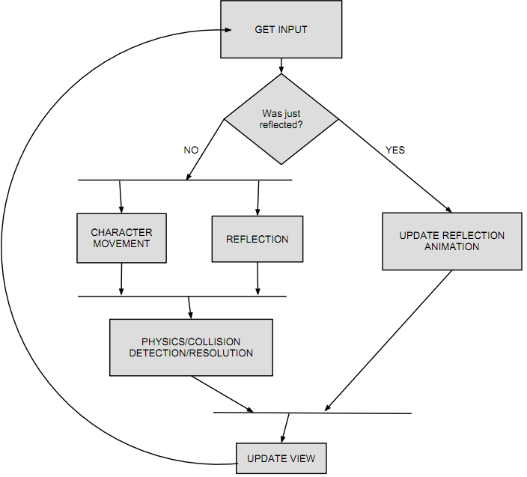

Collaboration Diagram
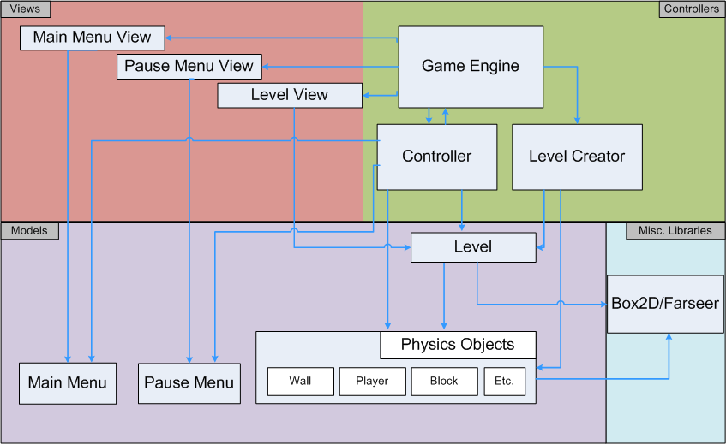

Class Interface Details

GameEngine
void Initialize() – Loads and initializes all textures, set the default values for the current Level, including width, height, gravity, and the Controller (this creates a new Controller)
void Update(GameTime) – Updates the game time
void Draw(GameTime) – Calls the draw method of the current level

PhysicsObject
void Initialize() – Sets all parameters for the physics object, indicating if it is destroyed, where it is positioned, and it’s initial velocity
void AddToWorld() – Adds a body to the PhysicsObject so physics can be applied to this object and all of its children

Player (extends PhysicsObject)
void Initialize() – Sets all parameters for the Player, including size, position, and sensors
Body CreatePhysics() – Creates the body for the Player and sets the shape as well as the friction and other fixtures
public Player(Level, Texture2D, int x, int y, float density, float friction, float restitution) – The Player constructor sets the initial value of all these parameters: current level, player’s texture, position, density, friction, and restitution

Wall (extends PhysicsObject)
void Initialize() – Sets all parameters for the Box, including position and reflect-ability
void Reflect(int start, int end, ReflectionOrientation ref_or) – Reflects the Wall about the reflection orientation passed in as a parameter. Updates the Wall’s current position to match the reflection.
Body CreatePhysics() – Creates the body for the Wall and sets the shape as well as the friction and other fixtures

Level
void Simulate(float dt) – Updates the state of the Level, by updating the state of all the PhysicsObjects present of the level. Also checks for input that can change the state of the Level.
void Reflect() – Calls the Reflect method for every PhysicsObject in the level, if the reflect input is detected
void MoveReflectionLineLeft/Right/Up/Down() – Four separate methods used to move the axis of reflection in the indicated direction.
void Draw() – Draws all PhysicsObjects contained within the Level. This method will eventually be switched into a LevelView class, because this method is outside the scope of a Model.

LevelCreator
object CreateObjectFromName(string class_name, object[] args) – Creates and returns an object from a string which is the name of class or its type, and throws an exception if the class is not found. Args is the arguments passed to the constructor. Equivalent of saying return new <class_name>(args[0], args[1], …).
void CallMethodFromName(object obj, string method_name, object[] arguments) – Calls the method obj.<method_name>(args[0], args[1], …, args[n -1]).
object[] ParseArguments(string args) – Creates the array of objects that is passed as arguments to functions. The arguments to a function are in comma separated format. So something like <Position>0,1</Position> will return new object[] {1, 2}. Note ParseArguments converts common types it can recognize. So the string “1” will be converted to the int 1, the string “true” to the boolean true and the string “1.234” to the float 1.234. If it can’t recognize it as an int or boolean or float it just passes it as a String object.
Level ParseLevelFromString/File(String str) – Attempts to load a valid XML file or string into memory so that it can then be parsed to create a level.
Object ParseNodes(XmlElement) – Takes a node of the XML string, creates an object from the tag name and recurses on the inner text and add/sets the children created to the object created by this node.

External Libraries

Farseer Physics
- Detect/handle collisions
- Simulate physics
- Creating joints

Data Representation Model

Save Game File
File Format: TXT
Information Included: Progress through the game will be linear and there will be no overall score, so the file will simply keep track of the furthest progress achieved in the game (the furthest level completed).

Game Level File
File Format: XML
Information included: One tag for each object in the level (walls, enemies, blocks, switches, etc). The level tag shall be the root tag.
- Root tag: <Level> contains subtags:
  - Width (integer)
  - Height (integer)
  - Gravity – sets the constant for acceleration due to gravity (float, float)
  - Dimensions – number of blocks by number of blocks(integer, integer)
  - CanReflectHorizontal, CanReflectDiagonal, CanReflectVertical - indicates which orientations of reflection are available for this level (boolean)
  - ReflectionLinePosition – currently selected reflected line(integer)
  - ReflectionOrientation – orientation of initial reflection line (H, V, or D)
- <Player> tag that contains tags for the player’s attributes such as Texture, Width, Height, Density, Orientation, Position, etc.
- <Wall> tag for a new wall at a grid location. Can contain tags such as Position, IsReflectable, Texture, Orientation, Density, Friction, Restitution, etc.
- <Door> tag which indicates the position of the exit door, as well as its initial orientation. Can contain tags such as Position, IsReflectable, Texture, Orientation, Density, Friction, Restitution, etc.
- <Switch> tag giving the location of any switches. Can contain tags such as Position, IsReflectable, Texture, Orientation, Density, Friction, Restitution, etc.
- <Block> tag for each block in the level that contains the blocks position and its reflectability. Can contain tags such as Position, IsReflectable, Texture, Orientation, Density, Friction, Restitution, etc.

How the level is processed
<Level>
<Player>
<Position>
<X>0</X>
<Y>0</Y>
</Position>
</Player>
</Level>

This creates a level and a player and places the player at position (0,0). Note the name of the tag corresponds with the object it wants to create. Suppose we want to create an object of the class XYZ then we have to have a tag <XYZ></XYZ>. If we instead write <XYX></XYX>, LevelCreator will try to create an object of class ‘XYX’ which shall throw an exception since class XYX doesn’t exist and LevelCreator will notify that the level file is corrupted.

So, when we input the above example to the LevelCreator class this is what shall happen:
- It reads the Level tag and creates a Level object (for sake of reference call it ‘lvl’). It does this by using the ‘Actuator’ class in CSharp which takes in a String input of the type of the class (“Level”) and returns an object of that type. It then recurses on the inner text.
- Next it reads the Player tag and creates a Player object in the same way (again, for sake of reference call it ‘ply’) . It then recurses on the inner text.
- Next it reads the Position tag and creates a Position object in the same way (again, for sake of reference call it ‘pos’) . It then recurses on the inner text.
- Next it reads the ‘X’ tag. Now, it sees that this tag has no child tags so it knows that ‘X’ is not an object but rather just a member of the parent tag (position). It tries to call pos.AddX(0) or pos.SetX(0) or pos.X(0) if these methods exist in the pos object. Note that this requires that all classes with settable/addable member ‘XXX’ implement a SetXXX() or AddXXX() method or XXX() method. But since any class that has members that can be set use these setters or adders (that’s how we have designed our code), this makes things very convenient.
- Next it reads the ‘Y’ tag. Again, it sees that this tag has no child tags so it knows that ‘Y’ is not an object but rather just a member of the parent tag (position). It tries to call pos.AddY(0) or pos.SetY(0) or pos.Y(0) if these methods exist in the pos object.
- Next it adds/sets the ‘pos’ object. So it calls ply.AddPosition(pos) or ply.SetPosition(pos) or ply.Position(pos) if any of these methods exist.
- Next it adds/sets the ‘ply’ object. So it calls lvl.AddPlayer(ply) or lvl.Set Player(ply) or lvl. Player(ply) if any of these methods exist.
- Return the object created from the root tag, in this case lvl.

